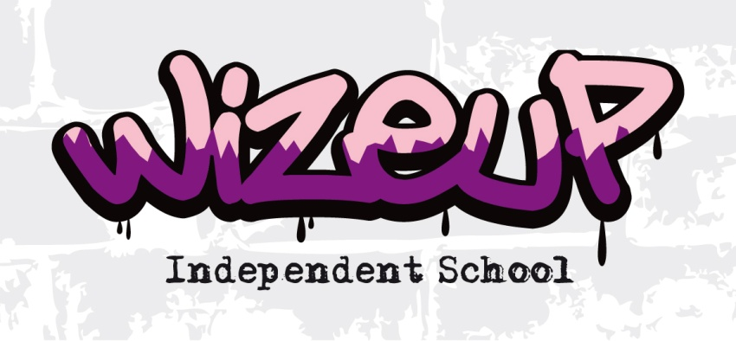
Complaints Policy
How to raise and resolve a complaint about your child’s education.
-----------------------------------------------------------------------------------------------------------------------
Although we do make every effort to ensure that your child’s education is a pleasant experience we also understand that things may go wrong and accept that parents/carers are keen to have these instances dealt with and resolved swiftly. Wize Up adopts an open door policy which enables parents/carers who do have concerns to get in contact with us and arrange an appointment with have their views heard in an informal setting. The aim of this is to deal with the problem and outline ways forward so all parties concerned are satisfied with the outcome and forward plans. Complaints that relate to child protection should be made directly to the school’s designated safeguarding lead Ms L Boyd or to the Local Safeguarding Children’s Board.
However should parents/carers wish to make a formal complaint they can do so through a set procedure. The first step in this procedure would be for a complaint form to be filled out and returned to:
Wize Up
Head Teacher, L Boyd
579 Westhorne Avenue
Eltham
London
SE9 6DN
who will reply within 5 working days. Should you not be satisfied with the response you have a further 5 working days to inform Wize Up of this. On receipt of this information you will be invited to attend a meeting (accompanied or alone) where your complaint can be heard by at least 3 individuals not directly involved in the issues relating to the complaint. You may be accompanied if you so wish by an advisor or friend. It is important to also note that one of these individuals on the panel will be independent from the running and management of the school.
Following this meeting the panel will reply sent by electronic mail or otherwise within 14 days to make recommendations and findings available to the complainant, Head Teacher and where relevant the person complained about. This report will also advise that any further appeal should be addressed to the Secretary of State.
All complaints are kept on file and are confidential, advising whether they were resolved at the first stage for if it was proceeded to a panel hearing. All complaints are confidential unless the Secretary of State or a body conducting an inspection under section 163 of the 2002 Act requests access to them.
For the academic year 2018- 2019 Wize Up received no complaints.
* complaint forms are available from the main office.

Wize Up Complaints Form
Please complete and return to Ms Boyd (Head Teacher) who will acknowledge receipt and explain what action will be taken normally within 5 working days.

Your Name: |  | Young Persons Name: |  | Your relationship to this young person:
Address:  Post Code: |  |  | Day time contact number
 |  |  | Evening contact number
Please give details of your complaint:

What action, if any have you already taken to try to resolve your complaint (who did you speak to and what was the outcome?)

What actions can Wize Up make that might resolve the problem at this stage?

Should you be attaching any documents please provide details:

Signature: |  |  |  | Date:
Official Use
Date acknowledgement sent: By Who:
Wize Ups actions and dates carried out:

Final outcomes:

Date:

Wize Procedure for Complaints being heard at Panel

The panel should take the following points into account:

- Although the hearing is a structured meeting it should be conducted as informally as possible.

- Witnesses are only required to attend part of the hearing to give their evidence.

- Once introductions have finished, the complainant is asked to give an account of their complaint, after which the witnesses will give their evidence.

- The Head Teacher may question the complainant and witnesses after each have given their account.

- The Head Teacher will then confirm the schools actions, after which the schools witnesses will also give their evidence.

- The complainant may question both the Head Teacher and the witnesses after each have given their account.

- The panel may at any point ask questions.

- The complainant will then be requested to sum up their complaint.

- The Head Teacher will then be asked to sum up the schools actions and response to the complaint.

- Both parties leave together while the panel decides on the issues.

- The chair explains that both parties will hear from the panel within a set timescale normally within 14 working days

